PADification User Interface Review

July 11, 2017

# Common elements

* Have Python script print when actions are performed: successfully changed passwords or new account created, monster has been added, etc.
* Conformity in the “Navigation buttons”.
* Any mention of showcasing monster point values or selling values?

## Login screen



Login:

* Change the screen to a smaller size?

Account creation screen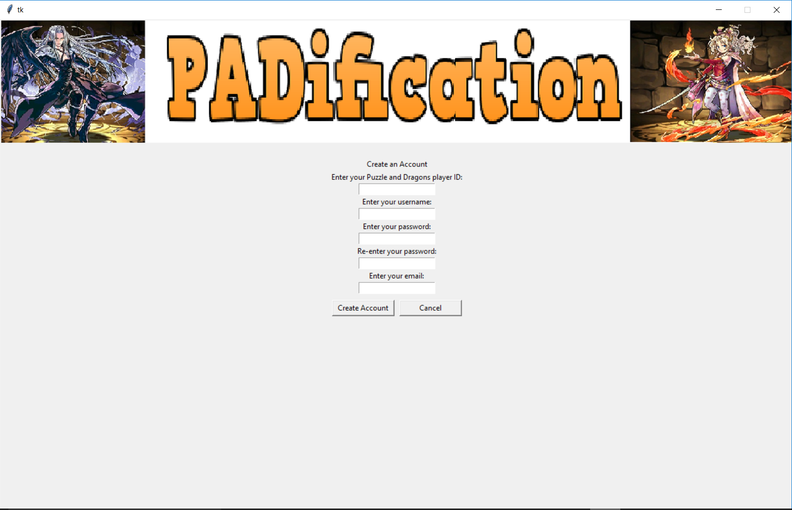

Account create:

* Needs more popup messages when filling fields incorrectly.
* Possible to sign-up with no Email
* Some fields need more attention when dealing with valid and invalid data.

## Home screen

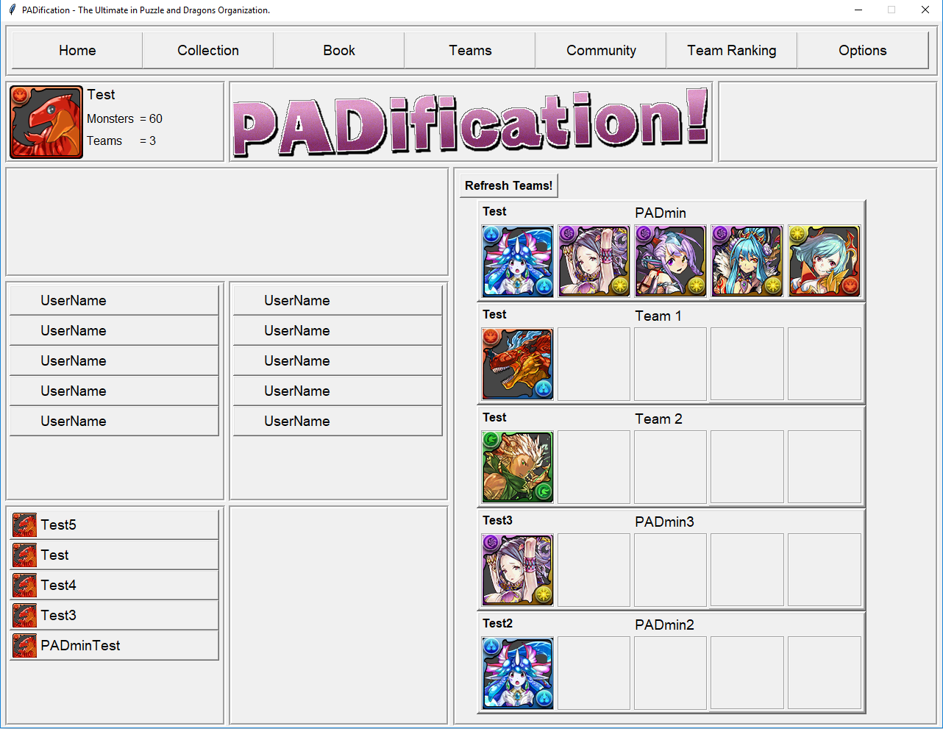

Home screen:

* Message popup when changing profile image with a name refers to monster ID as incorrect.
* When deleting a team leaving the total to 4 or less and refreshing, the last team slots do not update.

## Player collection screen

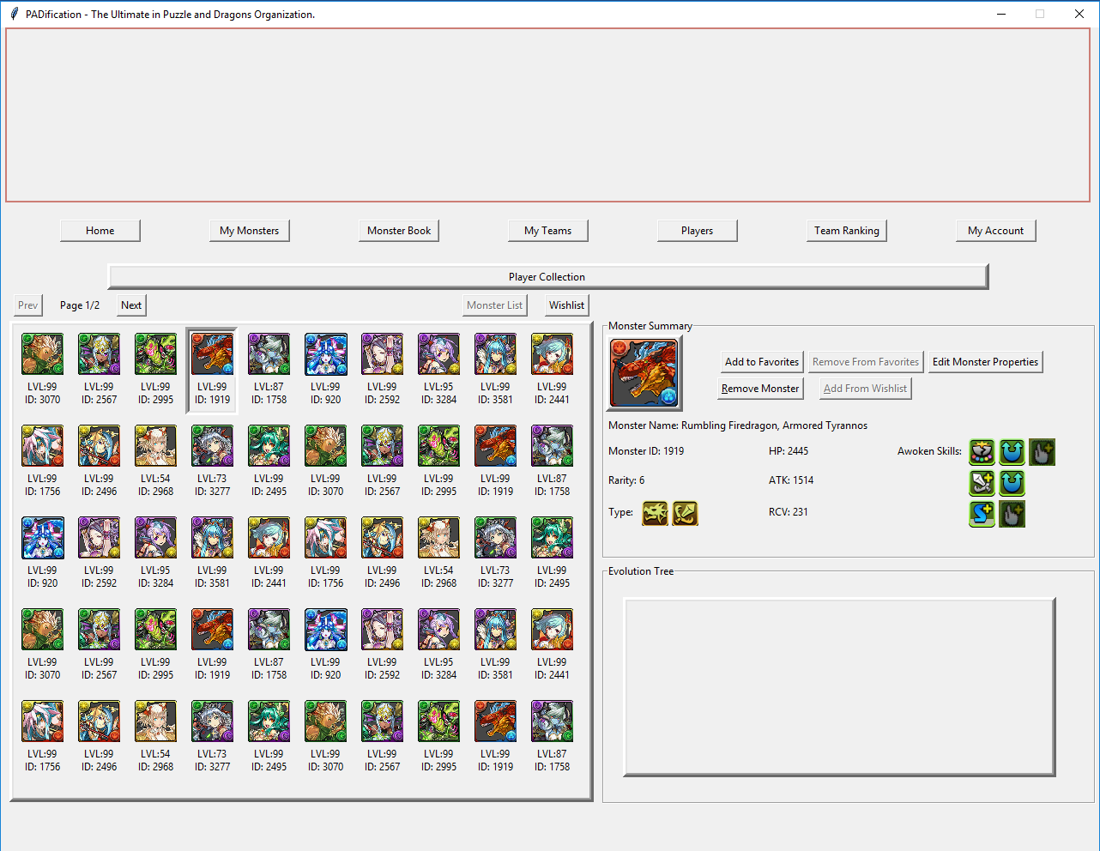

Collection:

* Reduce title size and use extra room for reformatting.
* No functions for favorited monsters or visual indicators.
* No indicators for monsters in use
* Awoken skills need a better linear format.
* No hover functionality
* No evolution tree display
* No skills display
* Add to favorites and Add from WishList should be the same button. It changes when a specific monster is selected. An add to Wishlist button could be added for adding new instances of a monster quickly.
* Missing space for Latent Awoken Skill and Assist properties.
* Should add filter options

## Edit monster / view monster screen

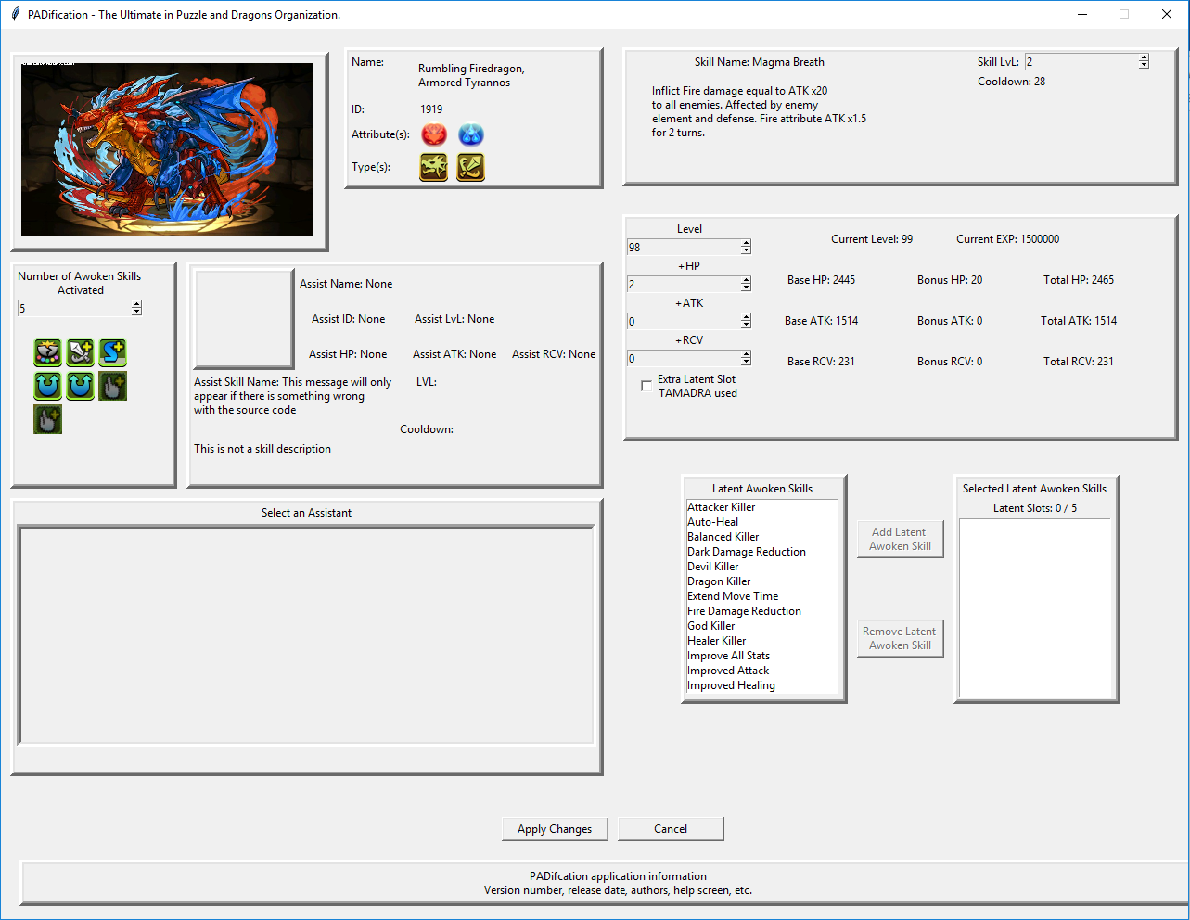

Edit monster:

* No hover functionality
* Monster image too small and cut off. Perhaps replace with profile image and use hover functions to view full image.
* Add icons next to modifiable fields for visual aid.
* Extra TAMADRA check box is strangely separate from its associated functions
* Latent skills should be grey and inaccessible when there are not enough points.
* Buttons act strange when selecting a 2-point skill when only 1 point is available.
* icons should be present with fields.
* Adding extra slot after 5 slots are reached does not open space for other skills to be added. But you can actually add another skill.
* It is possible to remove the extra when 6 slots are used.
* No visual affects to the awoken skills when changing numbers.
* No way to input numbers when changing stats
* Missing section for leader skills
* Current Exp could be renamed to approximate exp
* Cooldown is unaffected when raising or lowering the level. No indication of max level present,

## Monster book screen

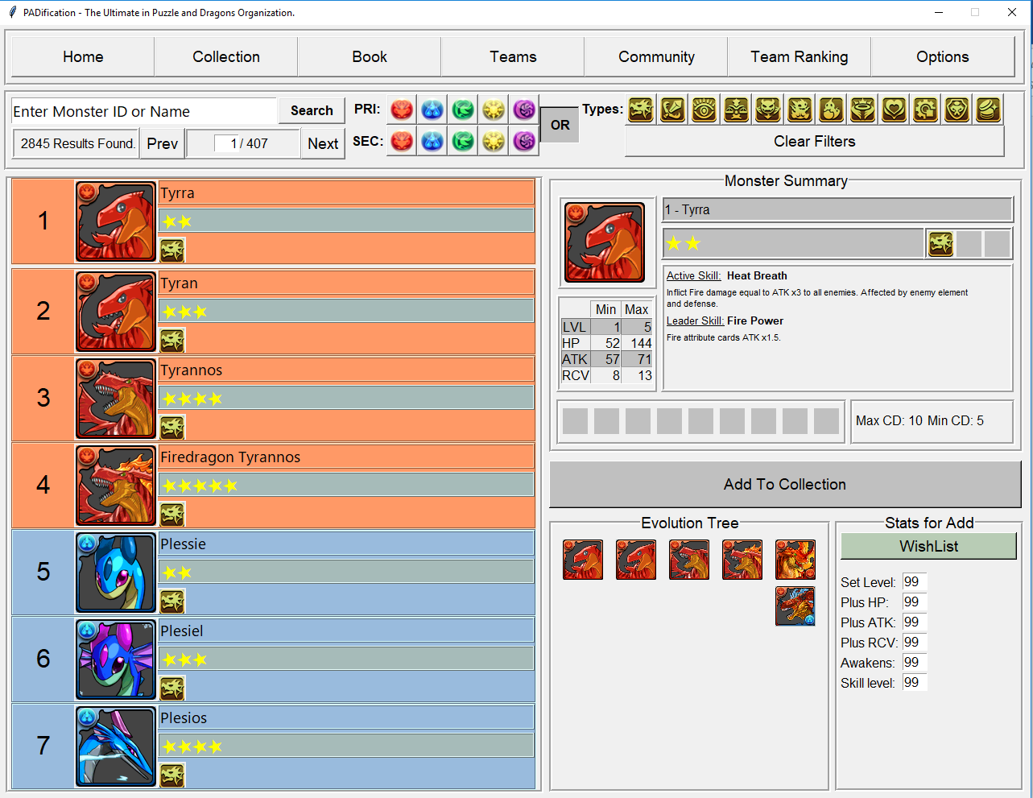

Monster Book:

* Evolution tree could use guidance in the form of arrows or other.
* When no monsters are found, there should be a message stating this fact.

## Team view screen

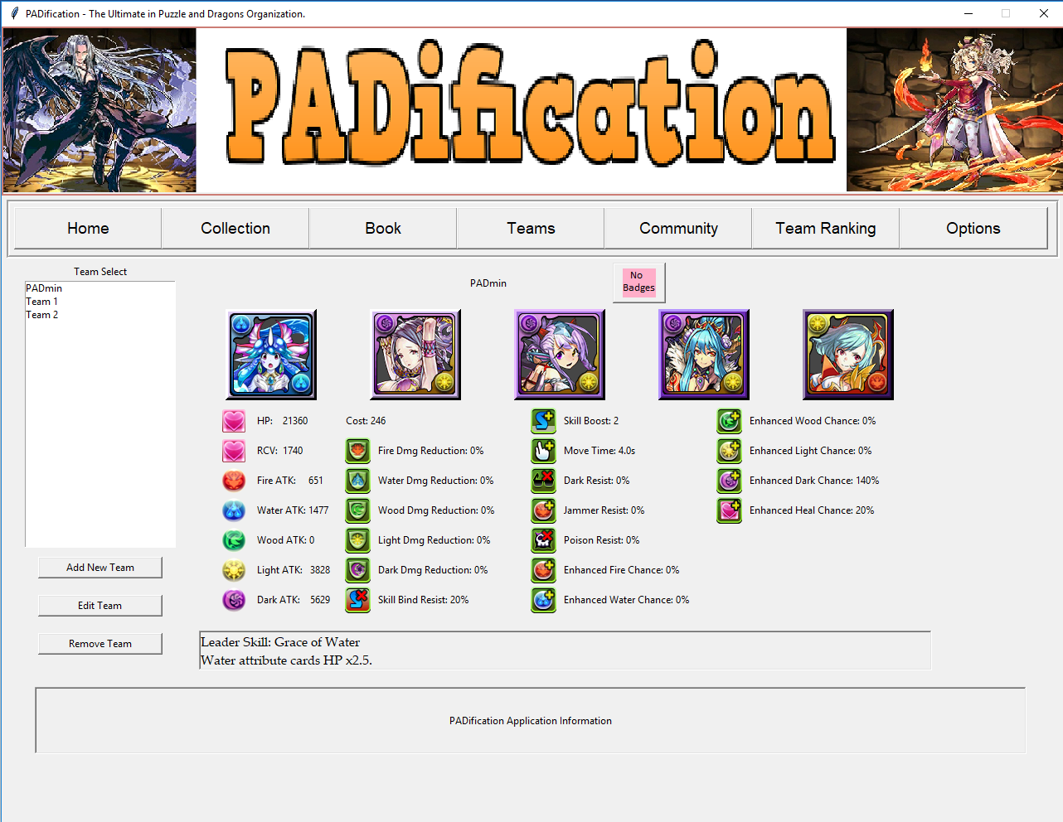

My teams:

* When a team with an inputted name is present and a new team is created with a default name, it reverts to team 1 even when two teams exist. (minor)
* No hover functionality
* Badges are left incomprehensible
* Missing confirmation for leader slot
* Missing button for team submission/retraction.
* Stat numbers could be set to sticky right for formatting.

## Edit team screen



Edit teams:

* No hover functionality
* Badges are left incomprehensible
* No way to add wish listed monsters to teams.
* Should add filter options
* Missing button for team submission/retraction. Instead of in place of My Teams screen.

## Account info screen

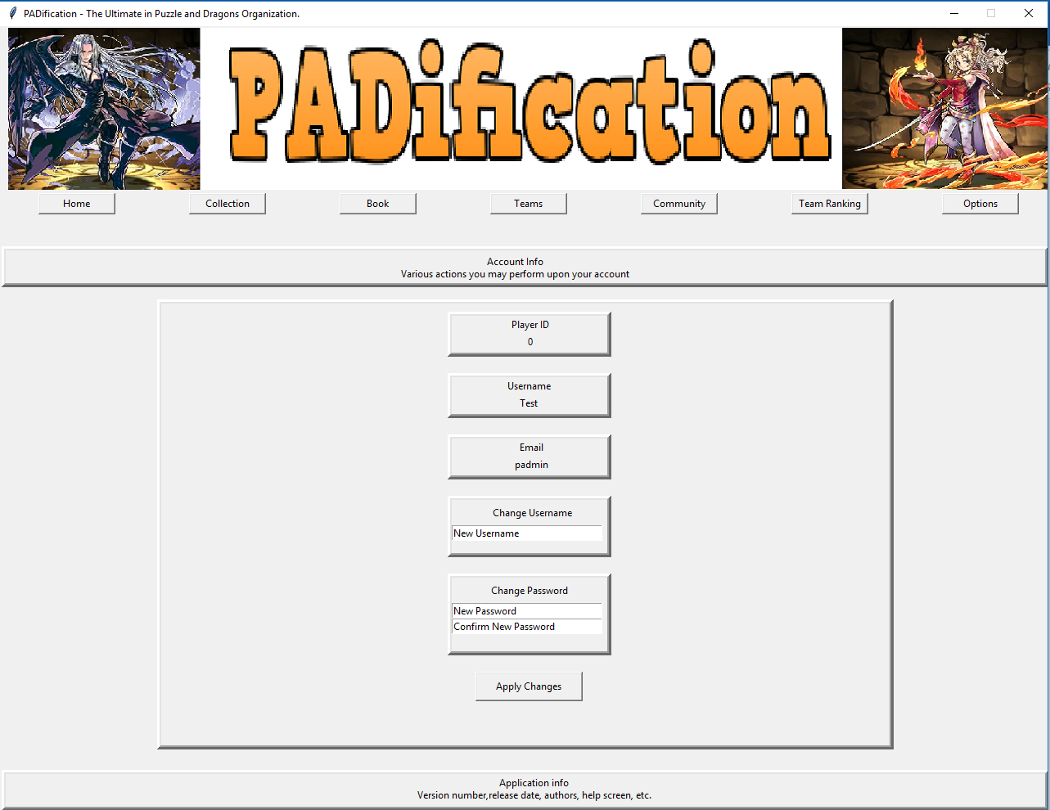

Account options:

* No popup window or confirmation when a change has been made.
* Changes are not saved once the application is closed
* Option screen could be reduced to a popup screen as its contents are small
* Add profile image modifier